NOTE: THIS ASSIGNMENT WAS SUBMITTED ON TIME, SCREENSHOT IS ATTATCHED AS PROOF THAT IS WAS UPLOAD ON THE DRIVE WITHIN THE SUBMISSION DATE AND TIME BUT COULD NOT BE UPLOADED ON MOODLE DUE TO AN UNEXPECTED ERROR SO KINDLY DON’T DEDUCT MARKS FOR LATE SUBMISSION, FURTHER PROOF WILL BE PROVIDED IF REQUIRED, THANK YOU

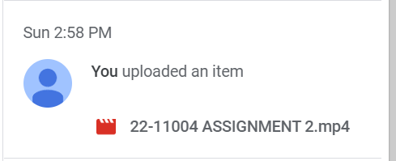

WAQAS RASHEED KHAN

22-11004

INFORMATION SECURITY SEC B

ASSIGNMENT 2

<https://drive.google.com/file/d/10dzMScqIziRUk3qhlml4oCM6XdCfyrpX/view?usp=share_link>